**KUBERNETES TASK – 03  
========================**

1. Create a ClusterIP service for an Apache web server pod.

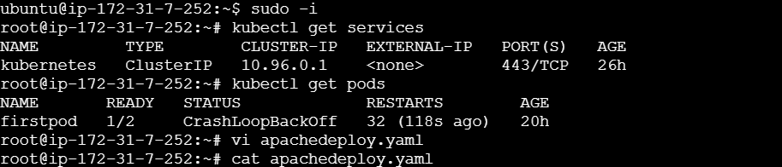

To apply the services or pods use this command

Kubectl apply -f apacheservice.yaml

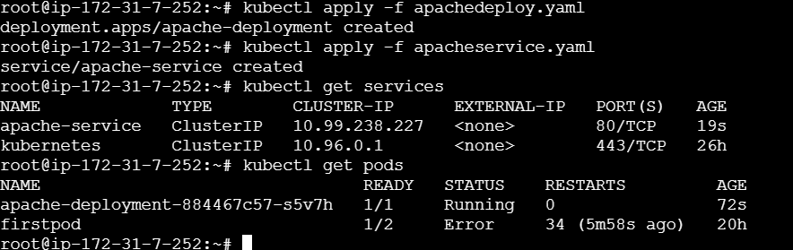

1. Expose an Nginx pod externally using a NodePort service.

kubectl expose pod firstpod --type=NodePort --port=8000 --target-port=80 --name nodeportservice

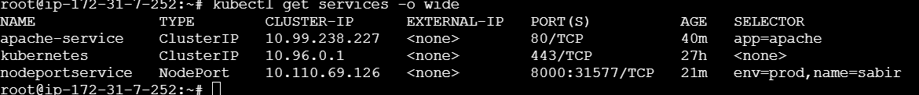

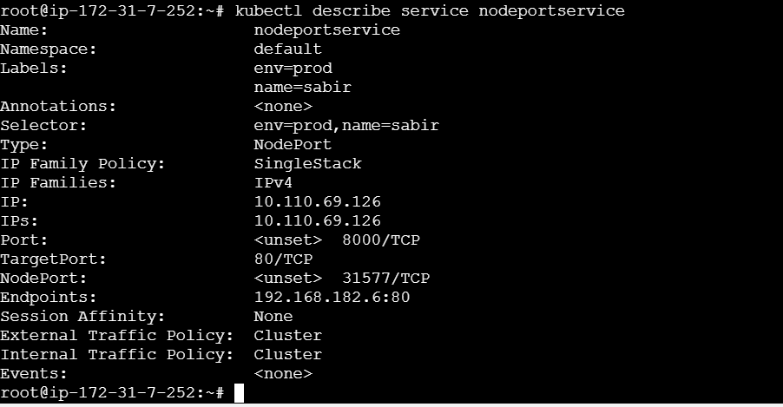

1. Deploy a ReplicationController to maintain 3 replicas of an Nginx pod.

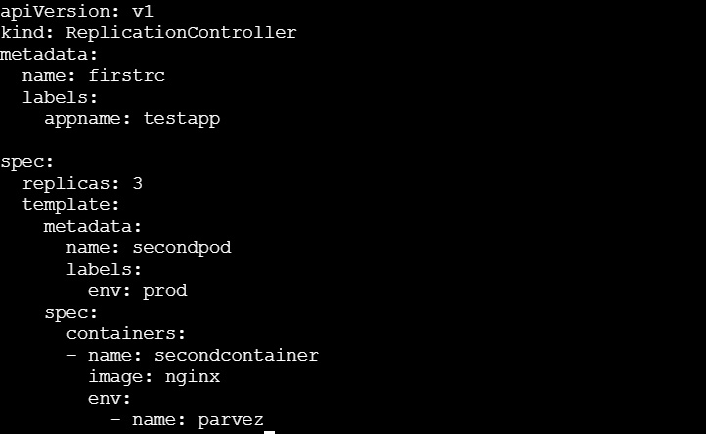

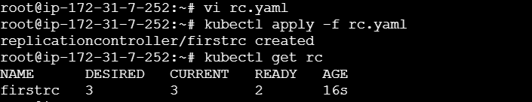

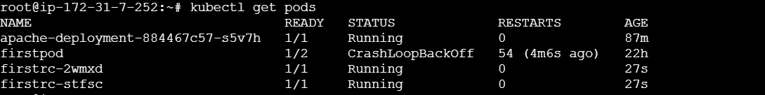

1. Scale the Replication Controller from 3 replicas to 5 replicas.



Kubectl get rc

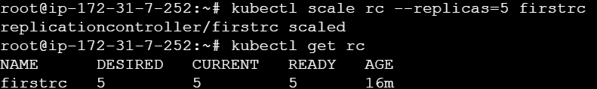

1. Create a ReplicaSet to manage pods based on multiple labels (prod and test).

Create vi rs.yaml rs replicasets

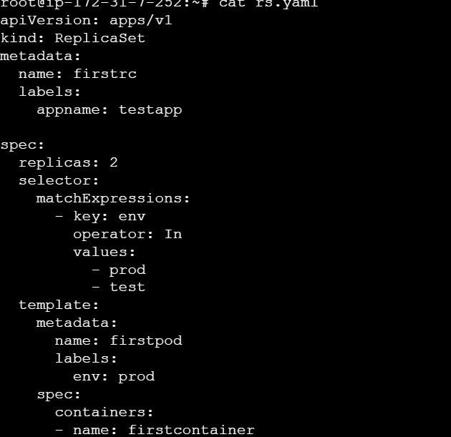

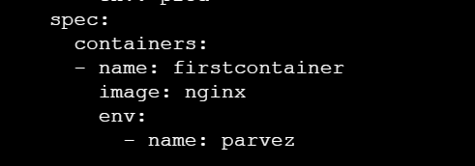

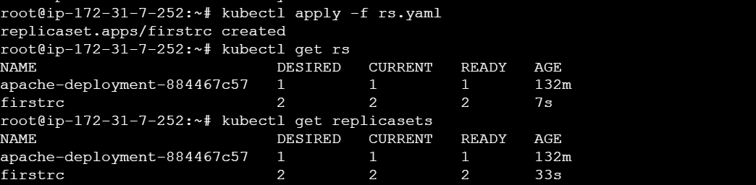

To show the labels we need to execute this command

kubectl get pods –show-labels

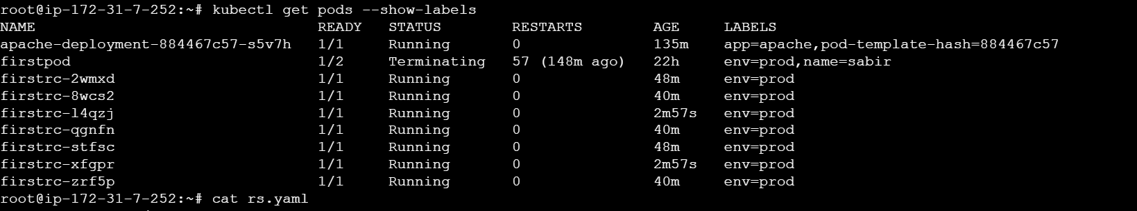

1. Deploy a ReplicaSet that excludes pods with the label backend.

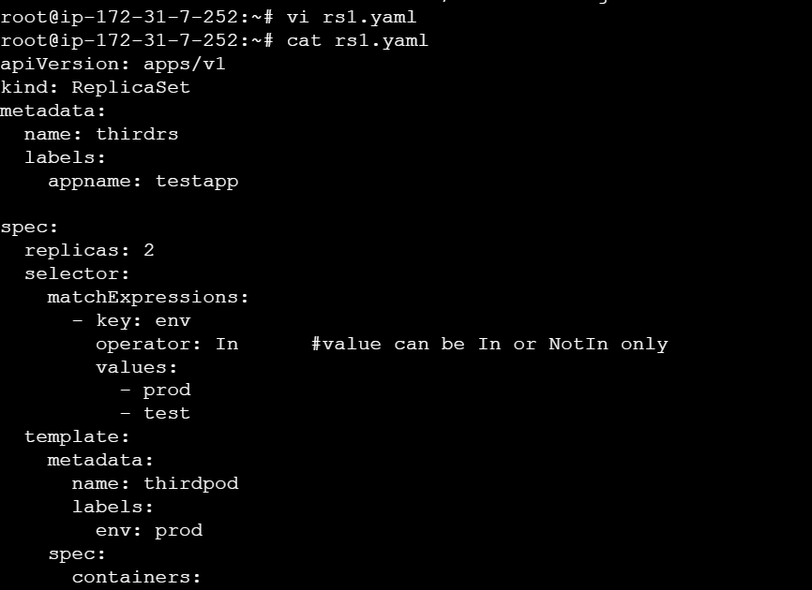

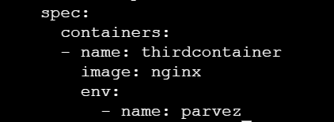



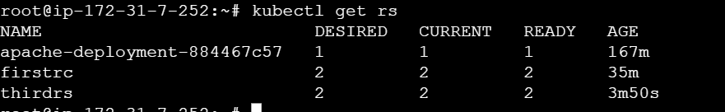

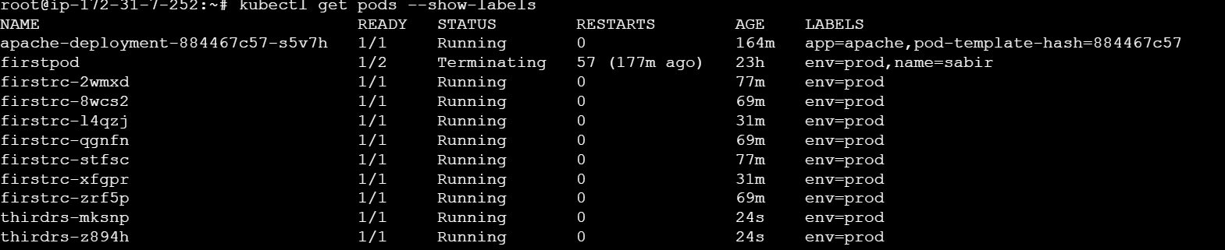

1. Test load balancing across multiple pods using a NodePort service.

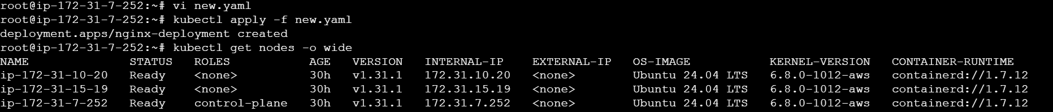

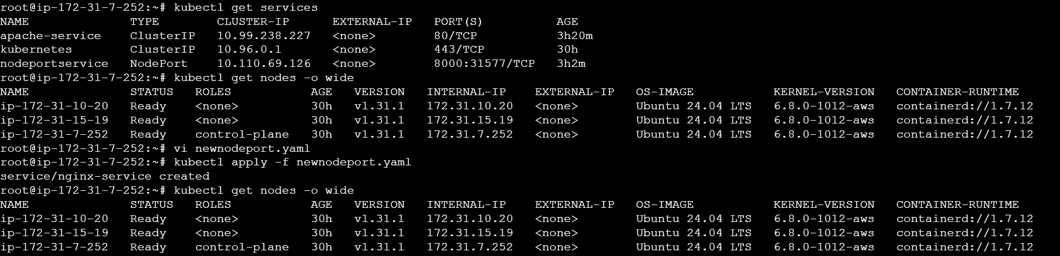

1. Delete a Replication Controller without affecting the running pods.

Before deleting we have on r c names firstrc

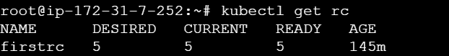

Kubectl get pods

